Project Planning Phase
Project Planning Template (Product Backlog, Sprint Planning, Stories, Story points)

Date | 14 July 2026
Team ID
Project Name | DARSHAN EASE (MERN Stack)
Maximum Marks | 5 Marks

Product Backlog, Sprint Schedule, and Estimation

Sprint | Functional Requirement (Epic) | User Story No. | User Story / Task | Story Points | Priority | Team Members
Sprint-1 | User Authentication | USN-1 | As a user, I can register using my name, email and password. | 3 | High | Team
Sprint-1 | User Authentication | USN-2 | As a user, I can log in securely using JWT authentication. | 2 | High | Team
Sprint-1 | Temple Exploration | USN-3 | As a user, I can view the list of temples. | 2 | High | Team
Sprint-1 | Temple Exploration | USN-4 | As a user, I can search temples by name or location. | 2 | High | Team
Sprint-2 | Darshan Booking | USN-5 | As a user, I can book available darshan slots. | 5 | High | Team
Sprint-2 | Temple Services | USN-6 | As a user, I can request Special Puja services. | 3 | High | Team
Sprint-3 | Donation Module | USN-8 | As a user, I can donate securely to temples. | 3 | High | Team
Sprint-3 | QR Ticket | USN-9 | As a user, I can view my QR-based booking ticket. | 3 | Medium | Team
Sprint-3 | Profile | USN-10 | As a user, I can view booking and donation history. | 3 | High | Team
Sprint-4 | Admin Dashboard | USN-11 | As an admin, I can approve or reject booking requests. | 5 | High | Team
Sprint-4 | Admin Dashboard | USN-12 | As an admin, I can approve or reject donations. | 3 | High | Team
Sprint-4 | Slot Management | USN-13 | As an admin, I can manage darshan slots and availability. | 4 | High | Team
Sprint-4 | Booking Management | USN-14 | As a user, I can cancel pending bookings. | 2 | Medium | Team

Project Tracker, Velocity & Burndown Chart:

Sprint | Total Story Points | Duration | Sprint Start Date | Sprint End Date (Planned) | Story Points Completed | Sprint Release Date
Sprint-1 | 20 | 6 Days | 05-Jul-2026 | 10-Jul-2026 | 20 | 10-Jul-2026
Sprint-2 | 20 | 6 Days | 11-Jul-2026 | 16-Jul-2026 | 20 | 26-Feb-2026
Sprint-3 | 20 | 6 Days | 27-Feb-2025 | 04-Mar-2025 | 20 | 04-Mar-2025
Sprint-4 | 20 | 6 Days | 05-Mar-2025 | 10-Mar-2025 | 20 | 10-Mar-2025

Velocity:

Assuming each sprint lasts 6 days and completes 20 story points:
Total Story Points per Sprint: 20
Sprint Duration: 6 Days
Average Velocity = 20 ÷ 6 = 3.33 Story Points/Day

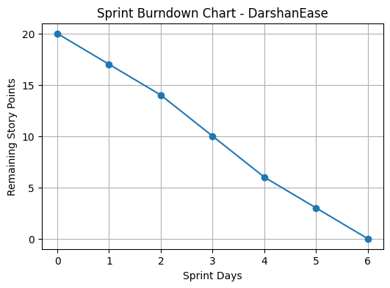
Burndown Chart:

